Cooks River Changemakers
Course Overview
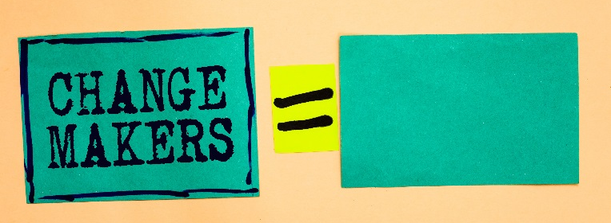
The Cooks River community is doing great things and you can be part of it!

Have you got a community river project or idea you are passionate about? Or just want to help the river but not sure where to start?

The Changemakers Course connects like-minded people to work together to create fun new projects that positively impact the Cooks River and its communities.

Together with experts, you'll explore the river, its issues and solutions and develop new exciting ways of drawing people to the river. The possibilities are endless.

The course will start with a tour of the Cooks River and catchment on Sunday 20th October 8am – 4pm.

Weekly evening workshops from 6pm – 9pm will run from Wednesday 23 October to Wednesday 11 December 2019, including a two-week class break during which you’ll have a go at running a mini prototype project. A graduation ceremony will be planned in February 2020. See the course schedule on page 3.

Visit the website to apply online or download an application form.
Applications must be received by: 9am Wednesday 9 October 2019

What is a community river project?
A community project involves members of the community taking action to improve, protect, nurture or increase awareness of the Cooks River. The list of possible projects is endless and we’ll you show some of the great ideas. Some examples include:
- Le Bushcare (practice French)
- Yoga or salsa dancing by the river
- Building a raingarden in a community space
- Promoting and planting wildlife habitat
- Leading specialised tours of the river
- Landcare for Singles

If you live/work/play in the Inner West and are interested in a developing a project focused on broader sustainability themes, consider applying for the Community Leaders in Sustainability Course which will run in early 2020.
How does it work?
The group will include up to 25 community members who live, work or study in the Cooks River catchment.

Workshops and field trips
There will be one field trip, six workshop sessions and a final graduation event.

The workshop sessions have guest presenters on topics such as transforming places and creating buzzworthy community events. At some sessions local community members will showcase their projects and discuss their experiences, successes and challenges.

As the weeks progress, groups will form to plan and deliver a project with a pilot test run after session six. Whatever stage you are at, you’ll have support to plan it and link with others who can help you.

What do we ask of you?
If you are a successful Cooks River Changemaker applicant:
- We ask that you commit to and attend all sessions
- We ask that you will arrive at sessions on time
- We ask that you contribute to a community project
- We ask that you bring a positive, courageous and open outlook to all the activities we undertake together, along with a willingness to listen, to share, to contribute and to support and encourage those around you whenever you see the opportunity.

What is the Cooks River Alliance?
The Cooks River Alliance is a partnership between councils in the Cooks River catchment – Bayside Council, City of Canterbury Bankstown, Inner West Council and Strathfield Council. The Alliance uses the combined resources, experience, knowledge and skills within the councils and the community to address the complex environmental problems of the Cooks River

Have some more questions?
Talk to the course coordinators:
Catarina Fraga Matos 9707 5725 info@cooksriver.org.au
Sue Burton 9707 5724 info@cooksriver.org.au

COOKS RIVER CHANGEMAKERS – COURSE SCHEDULE

Session | Date & Time | Topic | Location
1 | Sunday October 20th 8am – 4pm | Bus tour of the river and catchment: from Yana Badu Wetland in Chullora to Kamay (Botany Bay). | Meet in Shakespeare Street, Campsie
2 | Wednesday Oct 23rd 6pm – 9pm | Transforming places | River Canoe Club, Marrickville (opposite Tempe Station)
3 | Wednesday Oct 30th 6pm – 9pm | Project Engagement Lab | River Canoe Club
4 | Wednesday Nov 6th 6pm – 9pm | Facilitation skills training & working together | River Canoe Club
5 | Wednesday Nov 13th 6pm – 9pm | Project Accelerator Lab | River Canoe Club
6 | Wednesday Nov 20th 6pm – 9pm | Mini project activation planning | River Canoe Club
BREAK -- Two-week break to run your mini project prototype
7 | Wednesday Dec 11th 6pm – 9pm | Story sharing skill build. What’s next for your project? | River Canoe Club
Event | February 2020 TBC | Graduation Celebration | River Canoe Club

